**Unity + HoloLens 2 Tutorial**

1. **Environment**

Unity: 2019.2.18f1

SDK: 10.0.18362.0

Universal Windows Platform

MRTK 2.5.1

[Visual Studio 2019](https://visualstudio.microsoft.com/downloads/)

HoloLens 2

1. **Progress**
2. Unity

Install the Unity Hub and Unity 2019.2.18f1

1. Download the Unity Hub:

<https://docs.unity3d.com/2018.4/Documentation/Manual/GettingStartedInstallingHub.html>

Follow the order of the files in the link to complete the Unity 2019.2.18f1 installation.

1. Install the Universal Windows Platform on the Unity Hub

Click the Add Modules button, and the click the Universal Windows Platform button.

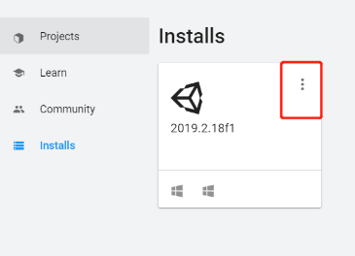 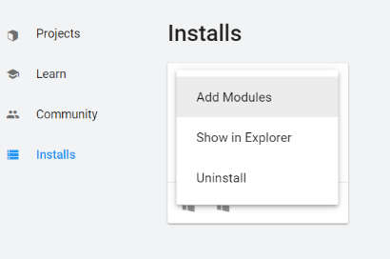 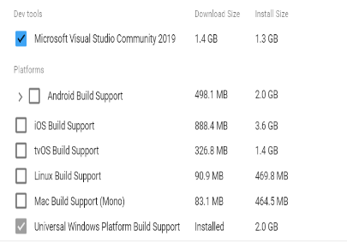

1. MRTK 2.5.1

Download the MRFeatureTool to install the MRTK 2.5.1 into the Unity

https://docs.microsoft.com/en-us/windows/mixed-reality/develop/unity/welcome-to-mr-feature-tool

Follow the order of the files in the link to complete the MRTK 2.5.1 installation.

1. Create a 3D project and build it
2. Create new scene: **File->New Scene**

b) Use the MRTK tool to create the initialization scenario. **Mixed Reality Tools -> Add to Scene and Configure**

c) Build the project: **File->Build Setting**

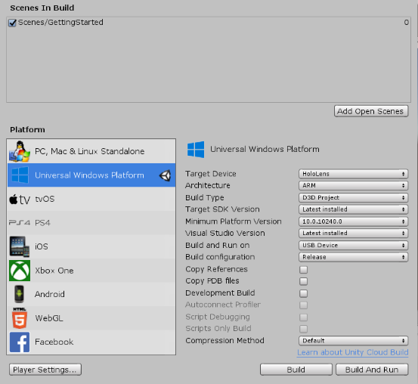 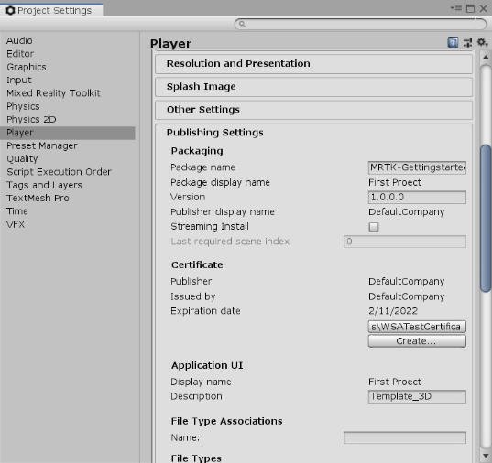

1. Test the project: Click the play button

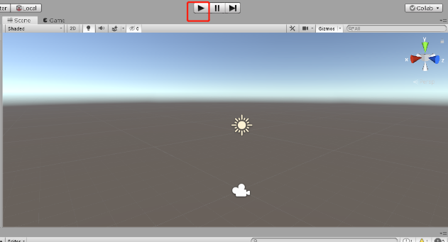 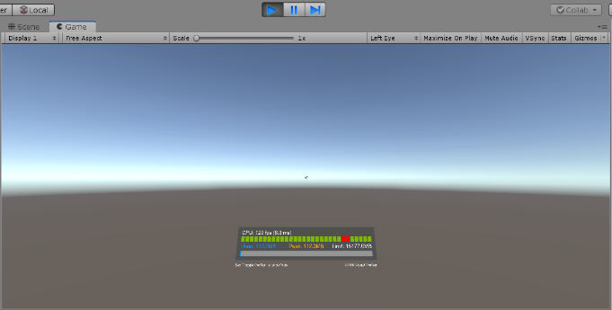

1. Running the .sln file

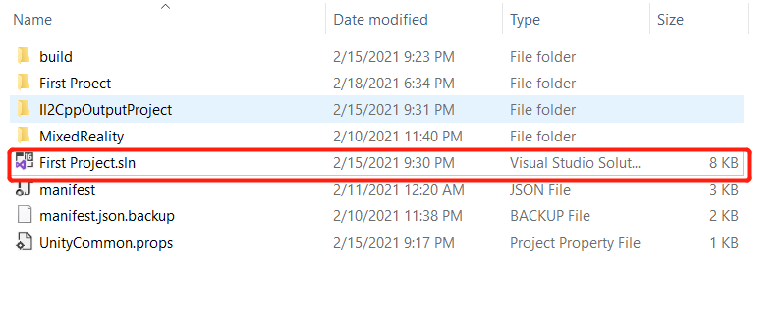

1. HoloLens 2 set up

Follow with the progress from this link: <https://docs.microsoft.com/en-us/hololens/hololens2-setup>

1. Connect the Visual Studio 2019 and HoloLens 2
2. Open the HoloLens 2 and open the Developer mode (Setting->update &Security->For develops->Developer mode)
3. Set up the [Visual Studio 2019](https://visualstudio.microsoft.com/downloads/)

!!Carefully: HoloLens 2 cannot connect with the Visual Studio when the IP address is 10.x.x.x, but it can be connected when the IP address is 192.x.x.x or 172.x.x.x.

1. Open the HoloLens 2 Device discovery to create a random PIN number
2. Input the PIN number into the Visual Studio When running the project